**Project Design Phase-II**

**Data Flow Diagram & User Stories**

|  |  |
| --- | --- |
| Date | 3 November 2022 |
| Team ID | PNT2022TMID41106 |
| Project Name | Analyticsfor Hospital Health Data |

**Data Flow Diagrams:**

A Data Flow Diagram (DFD) is a traditional visual representation of the information flows within a system. A neat and clear DFD can depict the right amount of the system requirement graphically. It shows how data enters and leaves the system, what changes the information, and where data is stored. 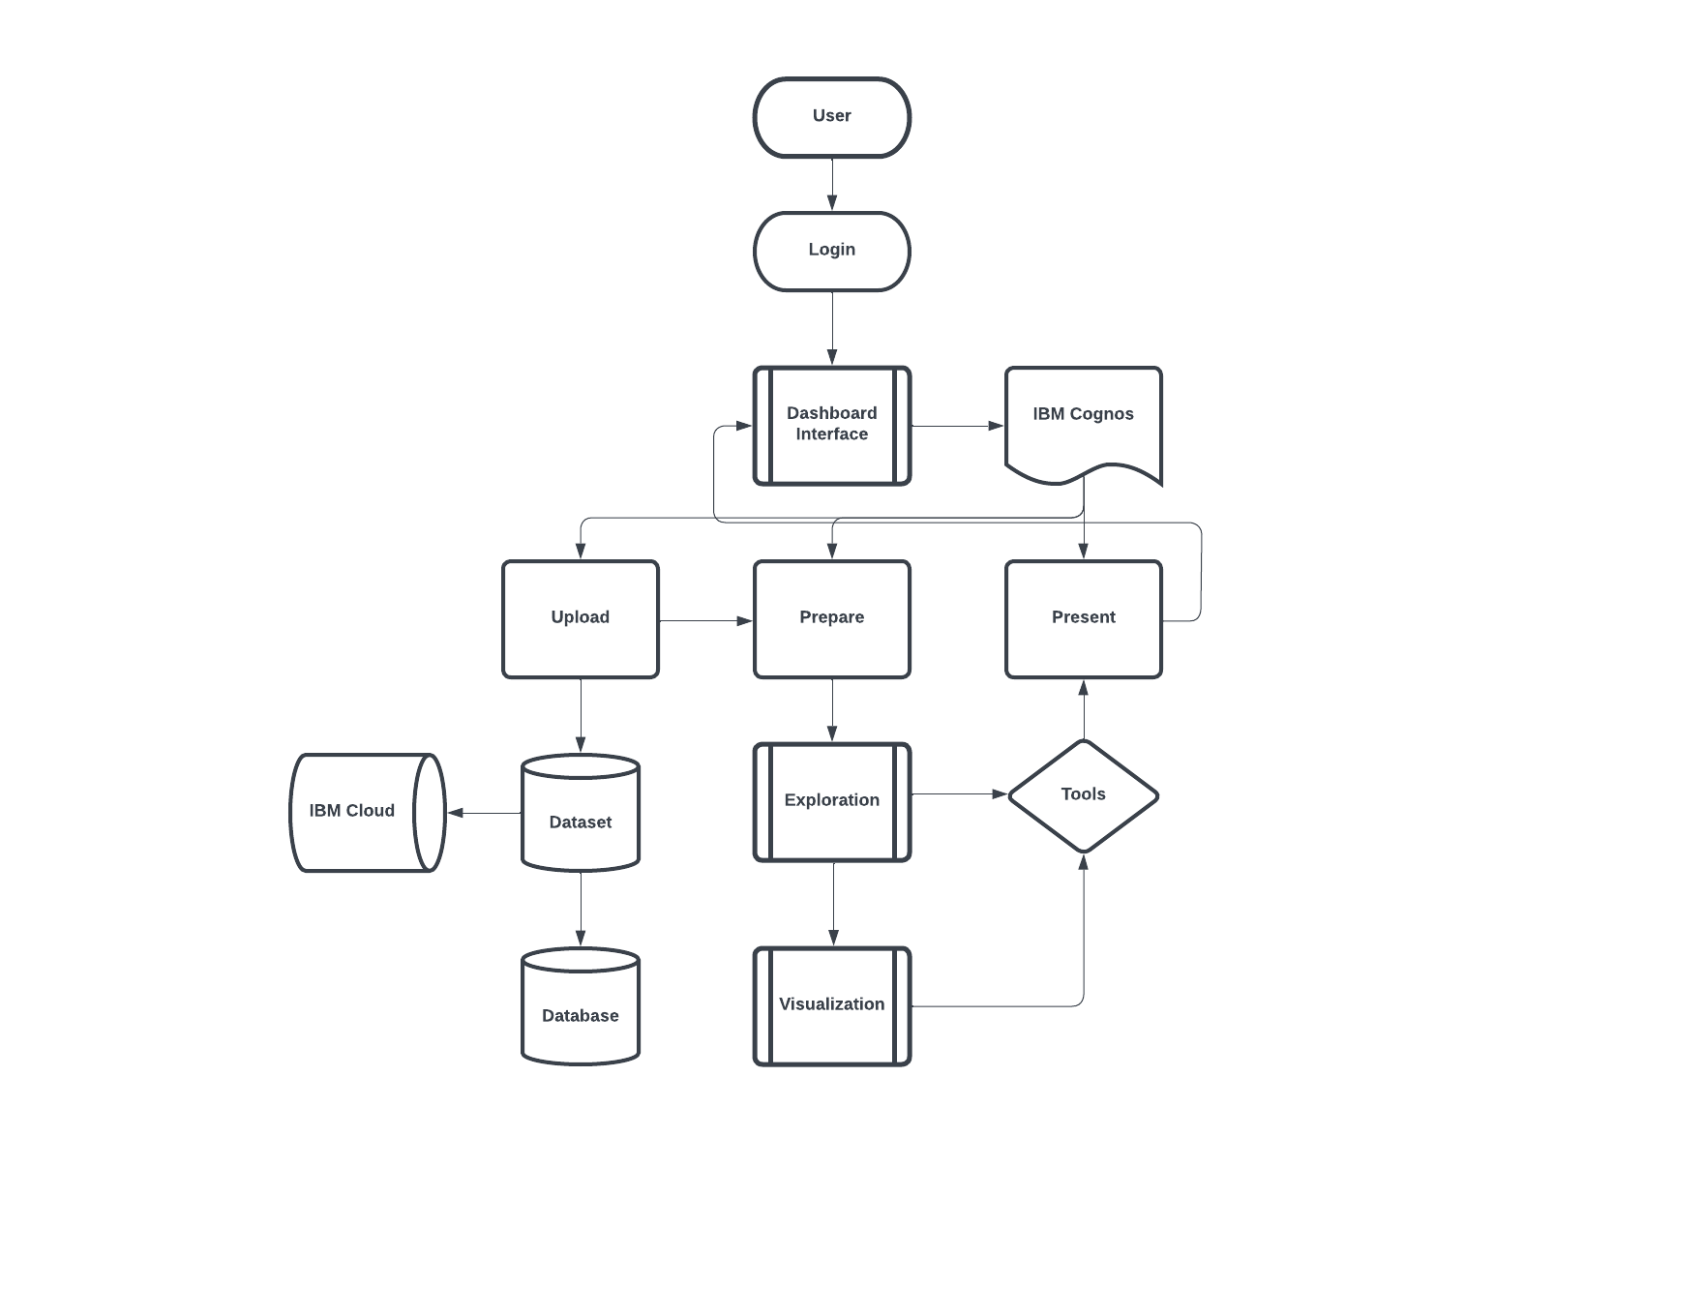

**User Stories**

Use the below template to list all the user stories for the product.

|  |  |  |  |  |  |  |
| --- | --- | --- | --- | --- | --- | --- |
| **User Type** | **Functional**  **Requirement (Epic)** | **User Story**  **Number** | **User Story / Task** | **Acceptance criteria** | **Priority** | **Release** |
| Customer  (Mobile user) | Registration | USN-1 | As a user, I can register for the dashboard by entering my email, and password, and confirming my password. | I can access my account in the dashboard | High | Sprint-1 |
|  |  | USN-2 | As a user, I will receive a confirmation email once I have registered for the dashboard | I can receive a  confirmation email & click confirm | High | Sprint-1 |
|  |  | USN-3 | As a user, I can register for the dashboard through Social Media | I can register & access the dashboard with Social Media Login | Low | Sprint-2 |
|  |  | USN-4 | As a user, I can register for the dashboard through Gmail | I can register and access dashboard with Gmail | Medium | Sprint-2 |
|  | Login | USN-5 | As a user, I can log into the application by entering email & password | I can login to the account in my email login. | High | Sprint-2 |
|  | Dashboard | USN-6 | As a user ,I can use my account in my dashboard for uploading dataset. | I can login to the account for uploading dataset. | Medium | Sprint-3 |
| Customer (Web user) | Website | USN-7 | As a user ,I can use my dashboard in website | I can login into the dashboard by visiting website. | Medium | Sprint-3 |
| Customer Care Executive |  | USN-8 | As a user ,I can contact Customer care Executive for my login. | I can contact customer executive for my login. | High | Sprint-4 |
| Administrator |  | USN-9 | As a user ,I can contact administrator for my queries. | I can contact administrator for solving my queries. | High | Sprint-4 |
| Exploration | Dashboard | USN-10 | As a user, I can prepare data by using Exploration Techniques. | I can prepare data by using Exploration Techniques. | High | Sprint-3 |
| Presentation | Dashboard | USN-11 | As a user, I can Present data in my dashboard. | I can present data by using my account in dashboard. | High | Sprint-4 |
| Visualization | Dashboard | USN-12 | As a user, I can Prepare Data by using Visualization Techniques. | I can prepare data by using Visualization Techniques. | High | Sprint-3 |